**Unveiling the Virtual Classroom: An In-depth Analysis of the Online Education System**

Dr. U. Surya Kameswari, Assistant Professor, Dept. of CSE, Acharya Nagarjuna University, [u.suryakameswari@gmail.com](mailto:u.suryakameswari@gmail.com), [suryakameswari@anu.ac.in](mailto:suryakameswari@anu.ac.in)

### INTRODUCTION

#### Overview

Online classes and technology have emerged as a superhero during the lockdown days. We have all been under house arrest but are still connected with the world of education. Due to the lockdown, students have not been able to stay connected with the outer world and the lack of exposure is evident. The only reprieve for the students’ mental well-being has been the transition to online classes. Teachers made sure that the learning for students was not compromised, so they took a great leap forward to find solutions and create new learning environments for their students to ensure that learning never stops. With the rapid advancements in technology and the widespread availability of internet access, online education has gained significant popularity in recent years.

This project aims to delve deep into the various aspects of online education, examining its strengths, weaknesses, opportunities, and challenges. The outcomes of this project will provide valuable insights for educational institutions, policymakers, and online learning platforms to enhance the effectiveness and accessibility of online education. This analysis of the online education system aims to contribute to the ongoing dialogue on the future of education and help shape a more inclusive, engaging, and effective learning environment in the digital age.

#### 1.2 Purpose

This study attempts to examine the many facets of online education in-depth, highlighting its advantages, disadvantages, opportunities, and difficulties. The results of this study will give educational institutions, decision-makers, and online learning platforms useful information to improve the efficacy and accessibility of online education. In order to contribute to the continuing discussion about education's future and to help create a more inclusive, interesting, and productive learning environment in the digital age, this analysis of the online education ystem is being published.

### 2 LITERATURE SURVEY

#### 2.1 Existing problem

Time management is undeniable that kids spend the entire school day on campus and that school days are hectic. Even if the students arrive home in the evening, fatigue sets in, and the remainder of the day is spent sleeping. This could seem like a negative when compared to online learning because the latter offers more time freedom. Since there is no commute time, the time saved can be used for other things, like hobby classes. In comparison to traditional classroom settings, online learning allows students to conserve energy and use it more effectively. A entirely different kind of curriculum that goes beyond textbooks and reading is required for offline education. When compared to online education, where you only need to pay for the internet and technology in addition to the fixed costs, this means that more resources are being used, which may be a disadvantage.

To this day, being able to record an ongoing lesson is nearly unheard of. You would therefore be fortunate to obtain recorded recordings of the sessions you attended in an offline educational setting; otherwise, you would have to settle with the notes you took in class. In comparison, online education is the complete opposite.

#### 2.2 Proposed solution

Through extensive data analysis and visualization features, the proposed system promises to improve education by utilizing the powerful capabilities of IBM Cognos Analytics. Institutions can discover more about student performance, course effectiveness, and learning outcomes by integrating this platform. Teachers and administrators can make well-informed decisions, allocate resources efficiently, and personalize learning with the use of interactive dashboards, predictive analytics, and adaptive learning capabilities. This data-driven strategy improves education standards and promotes ongoing development, resulting in a productive and interesting learning environment.

### 3 THEORITICAL ANALYSIS

#### 3.1 Block diagram

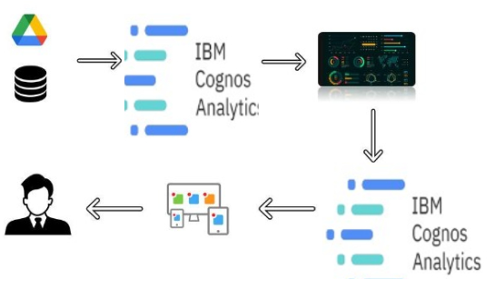

#### **3.2 Hardware / Software designing**

**Hardware Requirements:**

Operating System: Windows 8 or later

RAM : 4 GB

Hard Disk : 10GB

**Software Requirements:**

* IBM Cloud
* IBM Cognos Analytics
* Visual Studio Code

### 4 EXPERIMENTAL INVESTIGATIONS

The experimental research provides useful information about how IBM Cognos Analytics might affect online learning. The project seeks to improve the general standard of online education by analyzing student performance, identifying areas of concern, and customizing learning experiences. The findings are effectively communicated to educators, administrators, and policymakers through the use of interactive dashboards and storytelling methodologies, promoting the use of evidence in decision-making. This project seeks to further the continuing conversation about educational innovation and foster a more vibrant and productive learning environment in the digital era by utilizing IBM Cognos Analytics' capabilities.

### 5 FLOWCHART

### 

### 6 RESULT

##### **6.1 Loading the Data set**

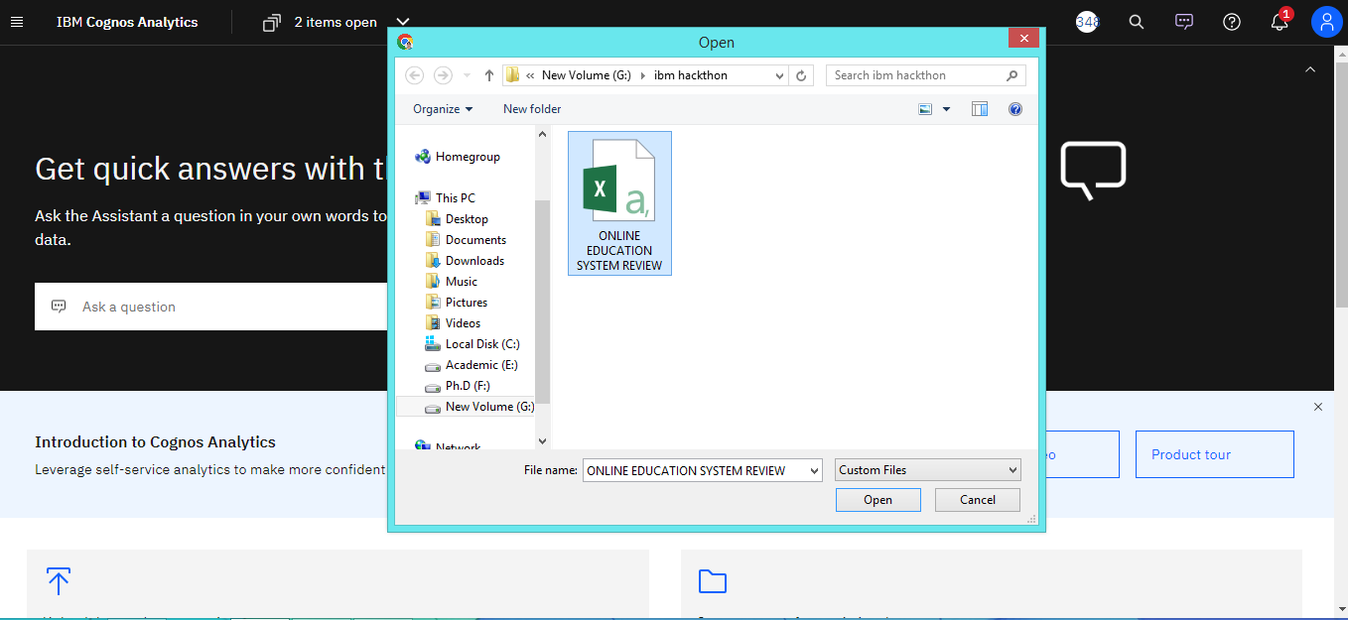

To create a module first we have to select data source.

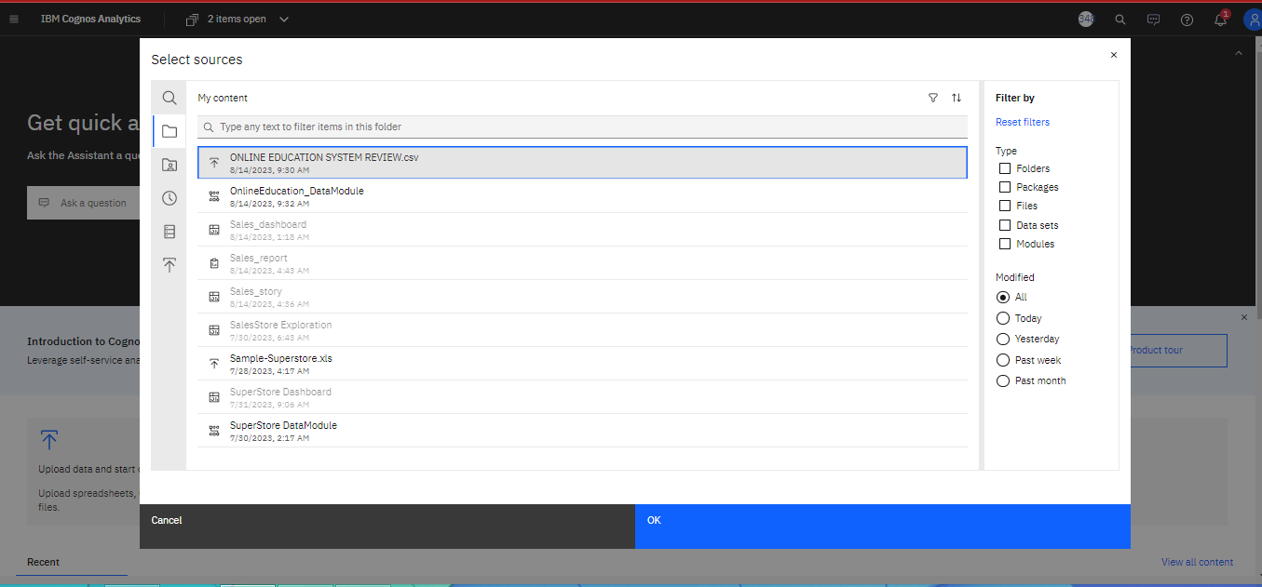

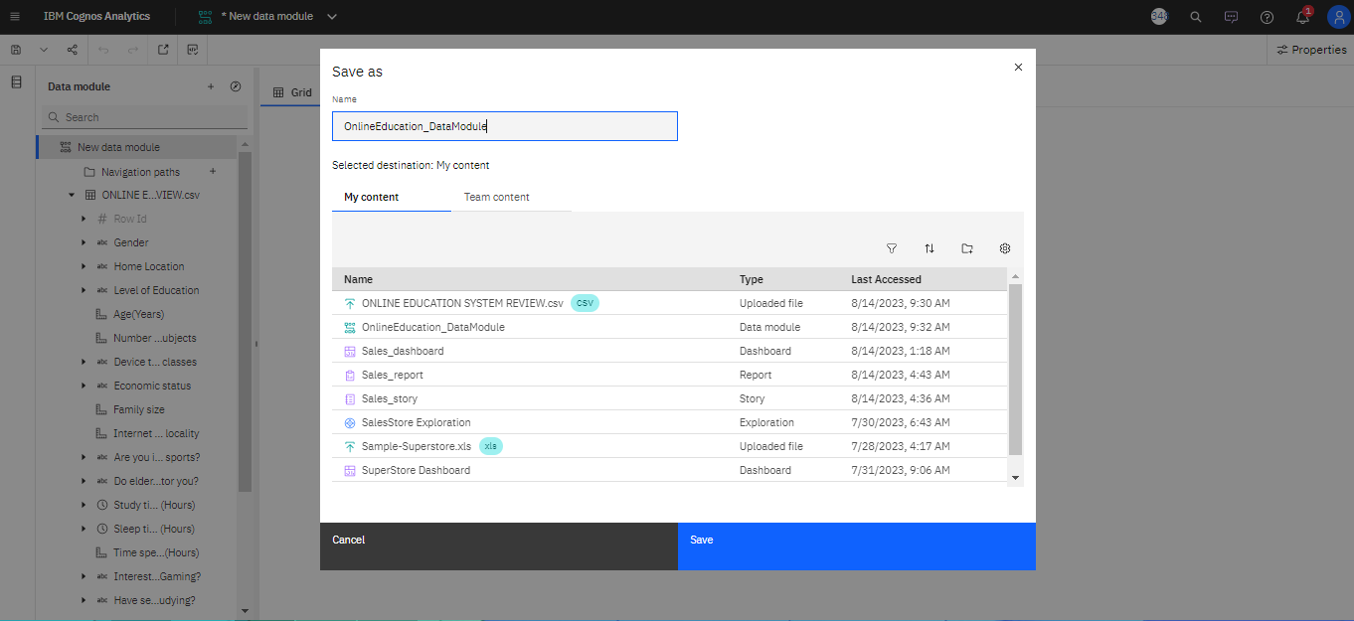

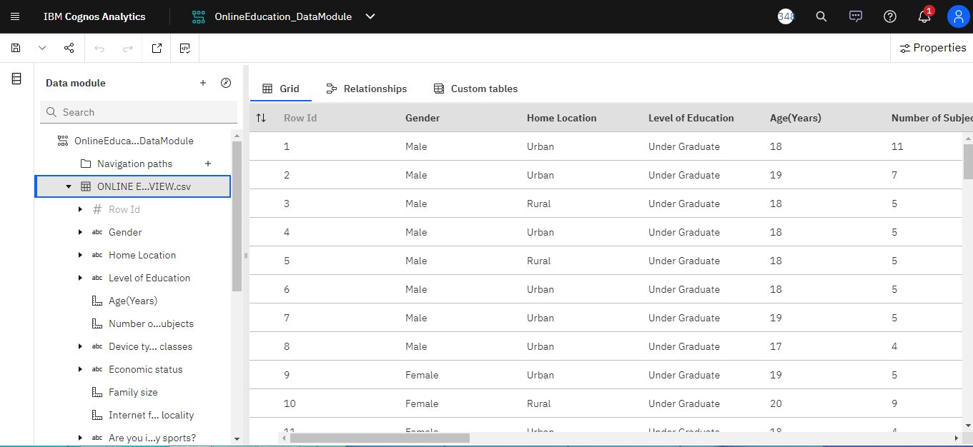

**The columns mentioned in the dataset says**

|  |  |
| --- | --- |
| 1.Gender – Male, Female.  2.Home Location – Rural, Urban  3.Level of Education – Post Graduate, School, Under Graduate  4.Age – Years  5.Number of Subjects – 1- 20  6.Device type used to attend classes – Desktop, Laptop, Mobile  7.Economic status – Middle Class, Poor, Rich  8.Family size – 1 -10  9.Internet facility in your locality – Number scale (Very Bad to Very Good)  10.Are you involved in any sports? – Yes, No  11.Do elderly people monitor you? – Yes, No  12.Study time – Hours | 13.Sleep time – Hours  14.Time spent on social media – Hours  15.Interested in Gaming? – Yes, No  16.Have separate room for studying? – Yes, No  17.Engaged in group studies? – Yes, No  18.Average marks scored before pandemic in traditional classroom – range  19.Your interaction in online mode - Number scale (Very Bad to Very Good)  20.Clearing doubts with faculties in online mode - Number scale (Very Bad to Very Good)  21.Interested in? – Practical, Theory, Both  22.Performance in online - Number scale (Very Bad to Very Good)  23.Your level of satisfaction in Online Education – Average, Bad, Good |

##### **6.2 Preparing Data Set**

Once the dataset is uploaded into the IBM Cognos dashboard, we need to prepare the dataset. The preparation includes cleaning up the data, removing the null values, removing the duplicate values, structuring the data. So that the data is well understood for exploration and analysis.

##### **6.3 Data Exploration**

###### **6.3.1 Student Satisfaction from Virtual Class Learning:**

Insight: Average is the most frequently occurring category of **Your level of satisfaction in Online Education** with a count of 541 items with **Your level of satisfaction in Online Education** values (52.4 % of the total).

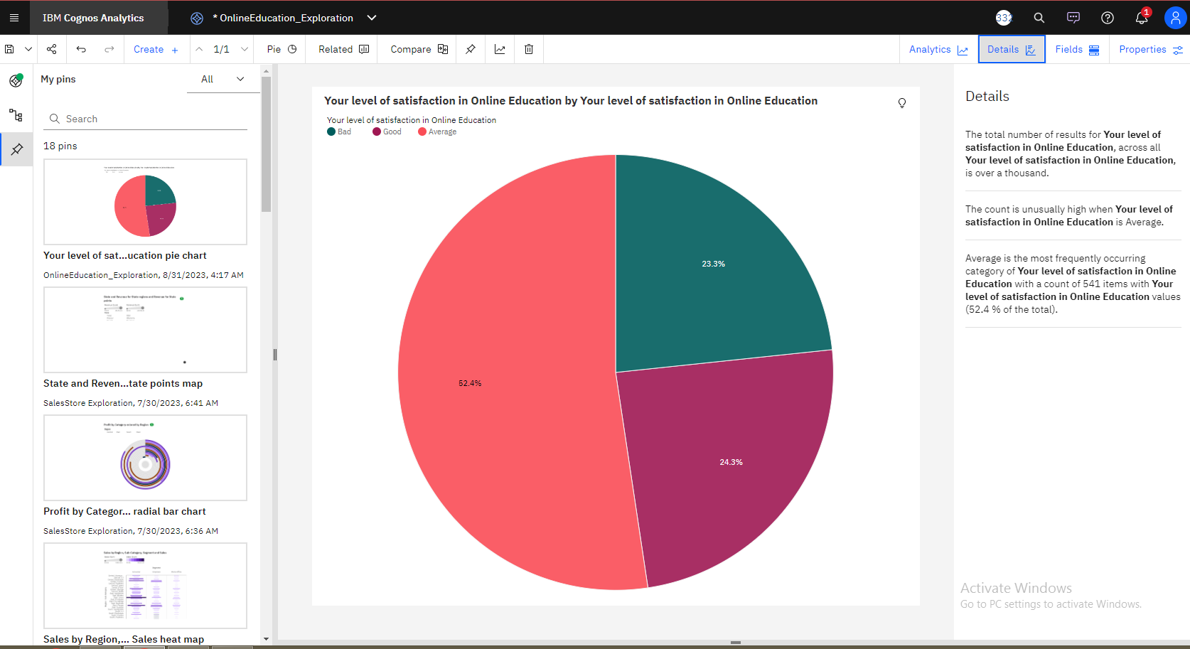

###### **6.3.2 Total Hours Accounted**

Insight: The counts are unusually high when the values of **Time spent on social media (Hours) +**are 14, 12 and 13.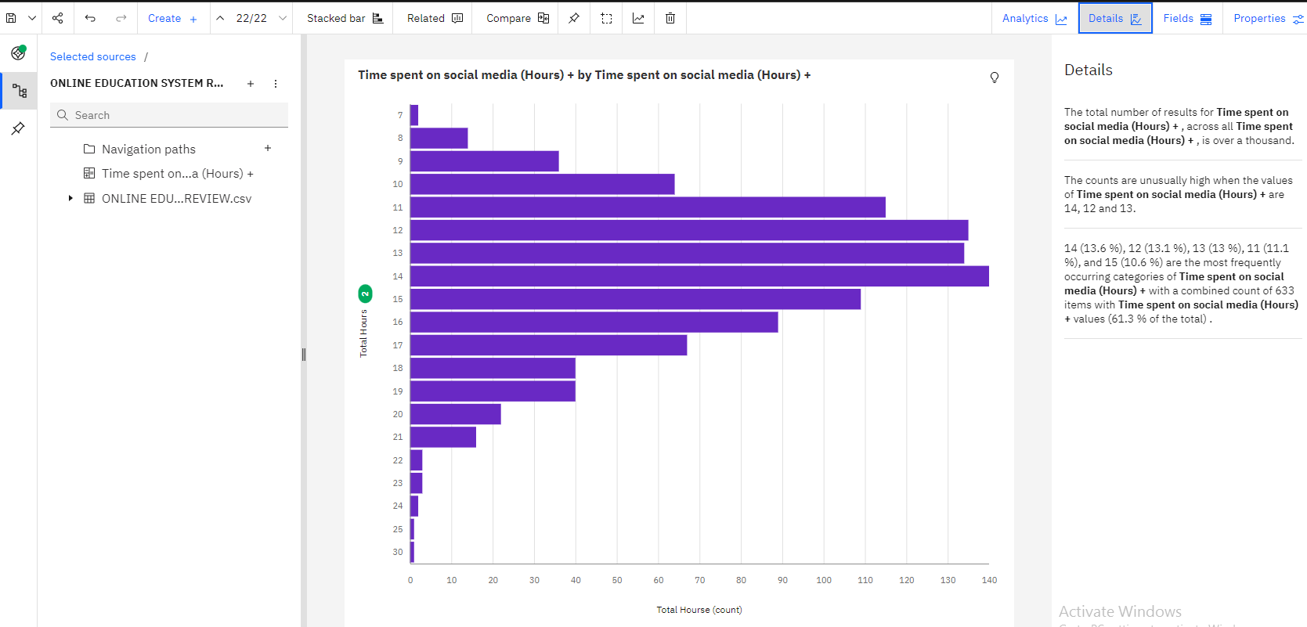

###### **6.3.3 Gender Ratio**

Insight:

Male is the most frequently occurring category of **Gender** with a count of 614 items with **Gender** values (59.4 % of the total).

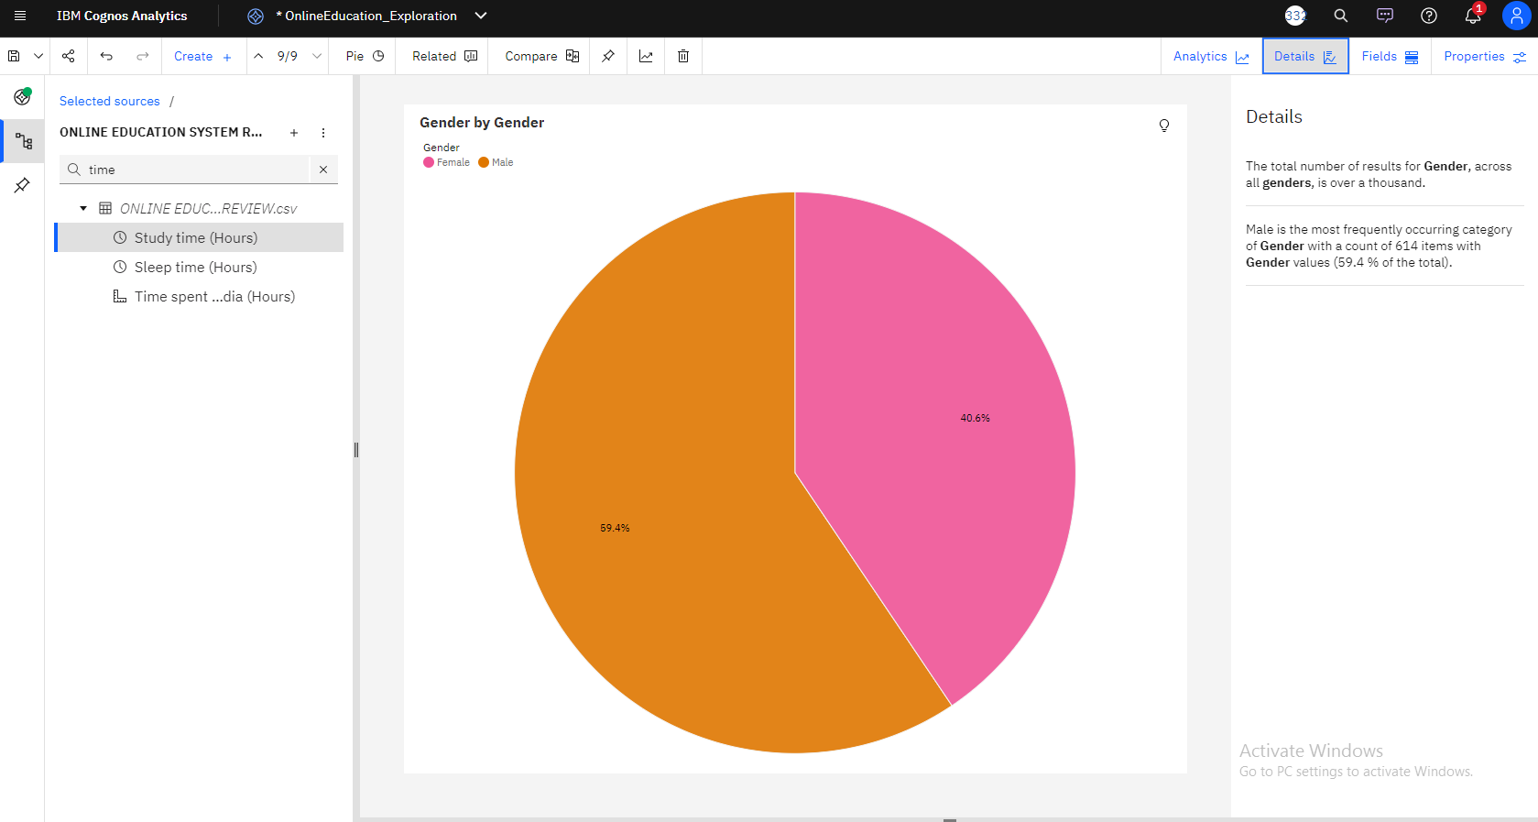

###### **6.3.4 Quality of Internet in Urban and Rural Areas:**

Insight:

The average values of **Internet facility in your locality** range from 3.184, occurring when **Home Location** is Rural, to 3.797, when **Home Location** is Urban.

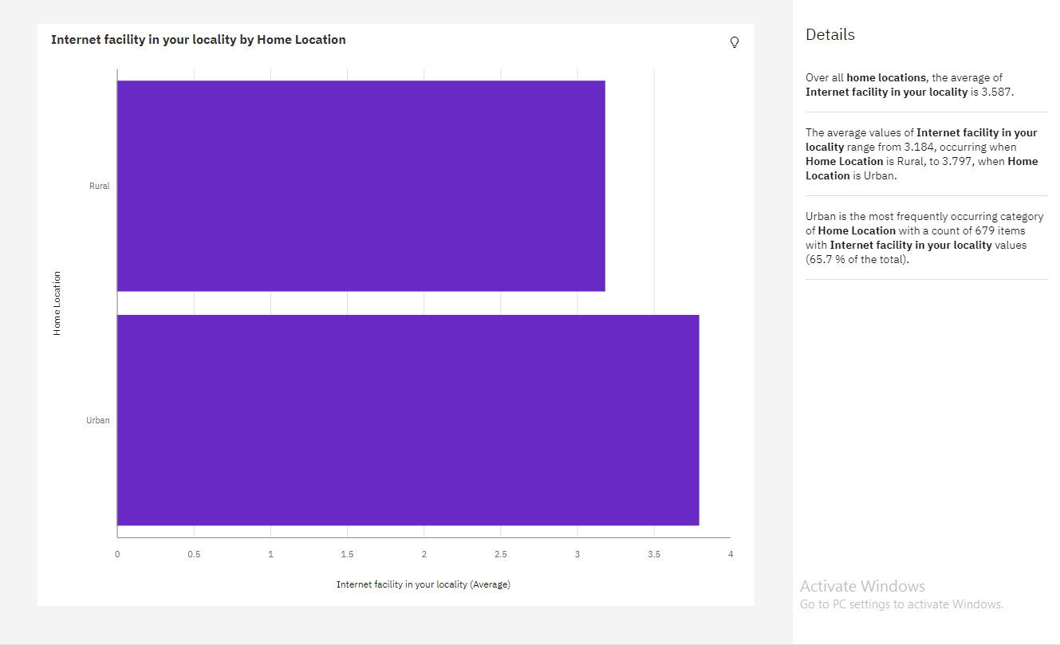

##### **6.4 Dashboard**

###### **6.4.1 Dashboard 1: Internet Facility**

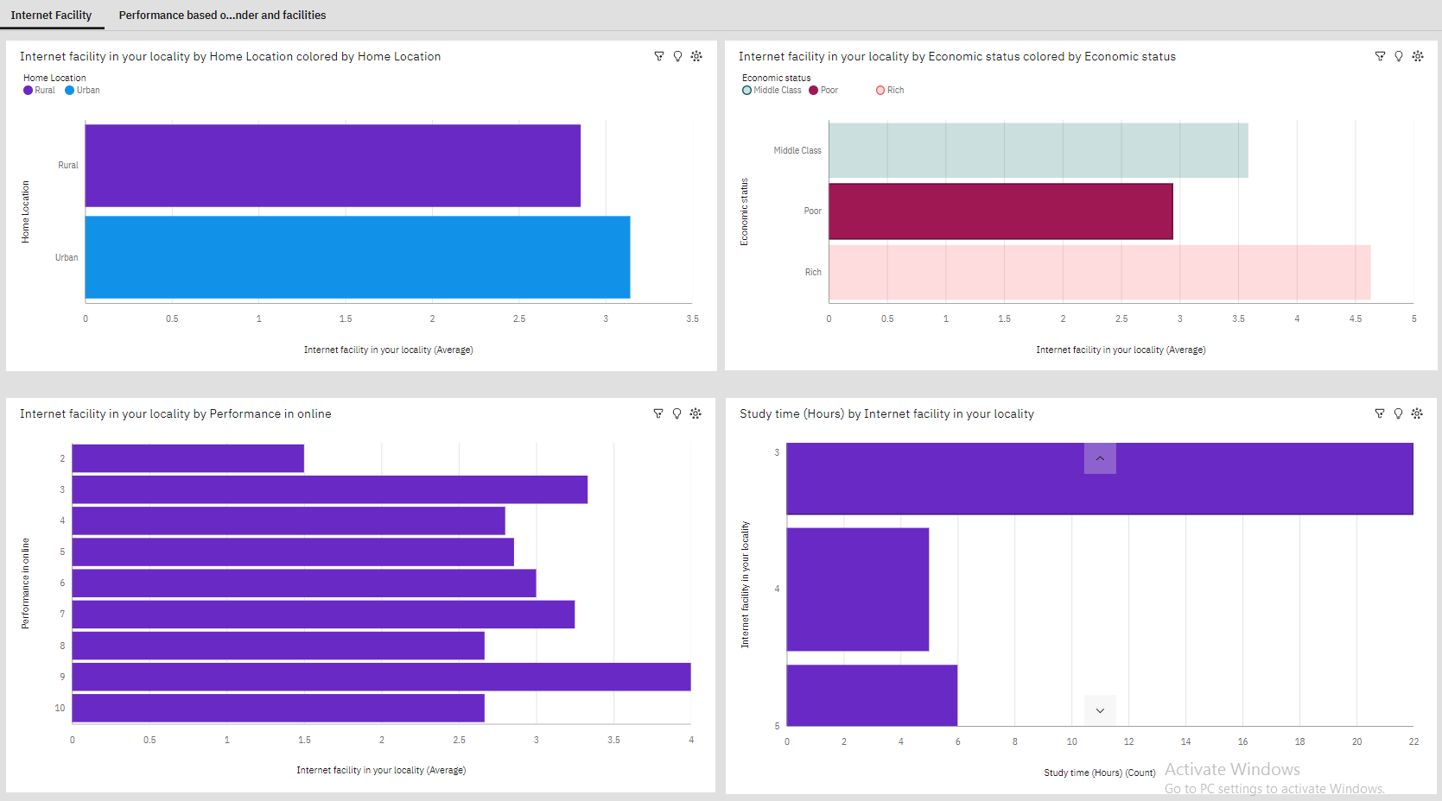

###### **6.4.2 Dashboard 2 : Performance based on gender and facilities:**

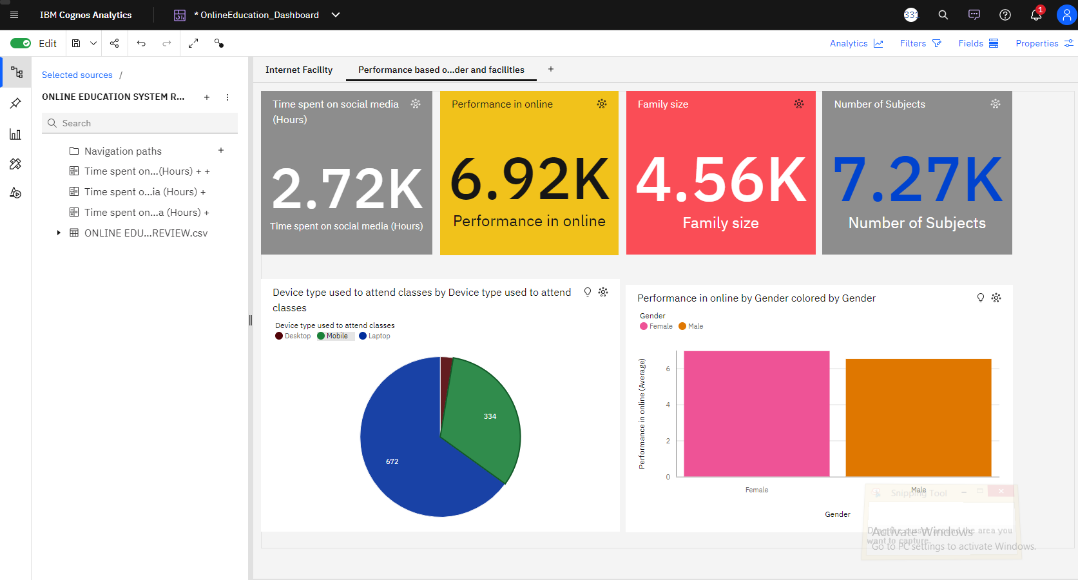

##### **6.5 Story Board**

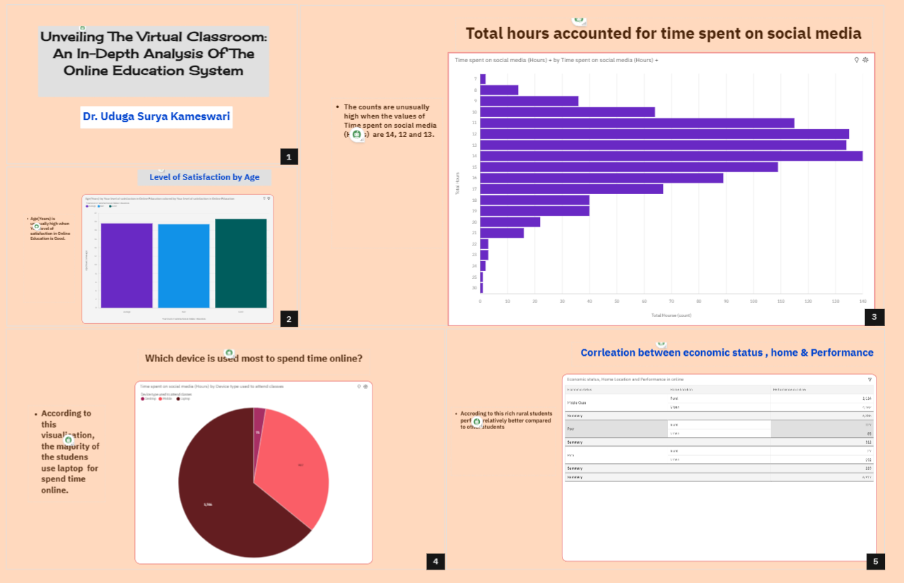

##### **6.6 Report**

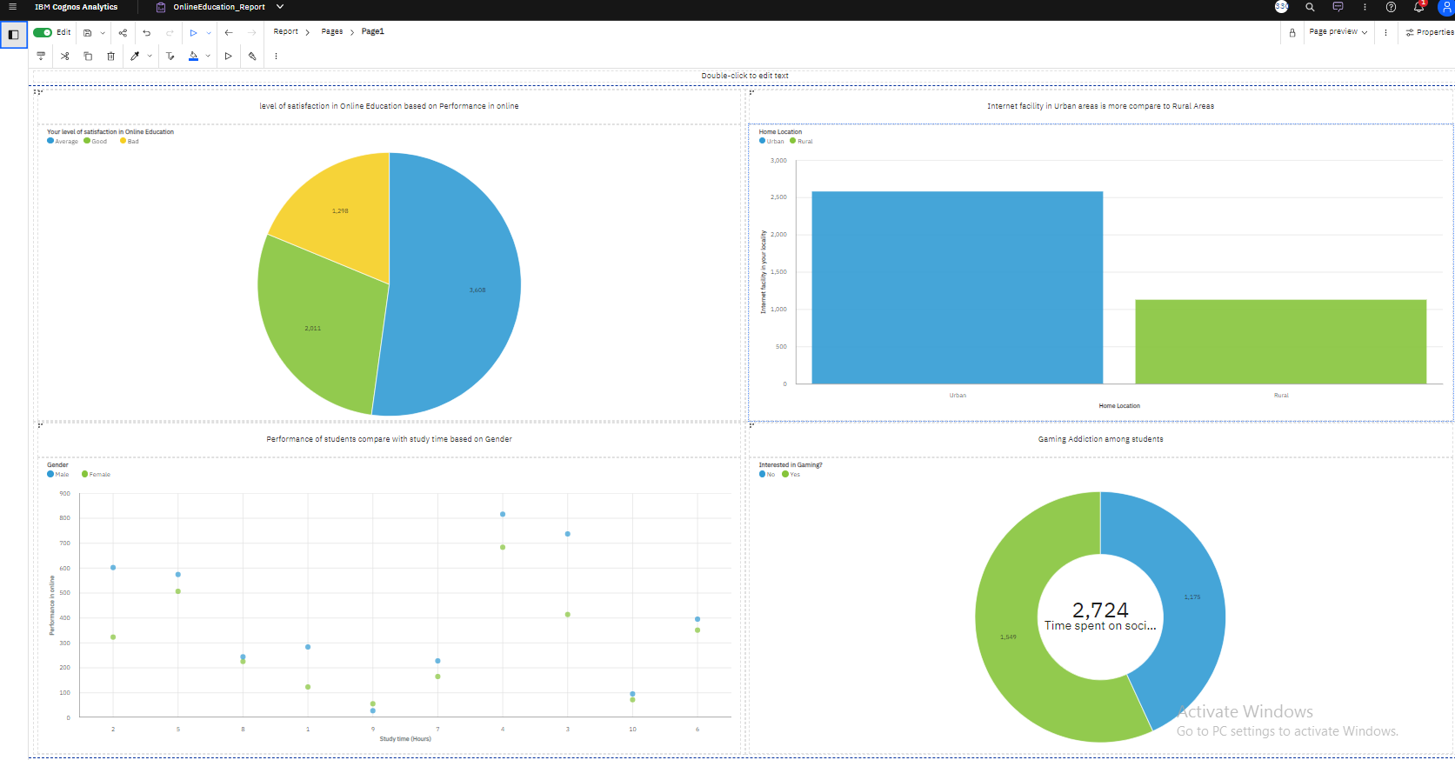

### 7 ADVANTAGES & DISADVANTAGES

##### 7.1 Advantages of Online Education

* Students can attend classes from home, allowing for greater schedule flexibility. They can schedule their day and divide their time. This flexibility lets students attend online lessons or enrol in other courses to learn about different interests. This expands their knowledge and personality. In addition, students can pursue offline pastimes. Online education is accessible anytime and anywhere with a reliable internet connection. Online lessons and sessions can be recorded for future reference, unlike offline lectures.
* Online education is fairly priced compared to traditional schools, which charge for transportation, uniforms, extra curriculars, and more. Other than fixed expenditures, the only costs are internet and devices, which most households have.
* We can come to conclusion that why Online education is more convenient than traditional schooling from the above reasons mentioned. Online classes make students more comfortable attending class. The medium saves students and teachers time and resources.

##### 7.2 Disadvantages of Online Education System

* Connectivity concerns are a major drawback. Technical issues may prevent online schooling due to unprecedented electricity and connectivity, depending on the location.
* Manage student focus is a major drawback of online education for teachers. It can be hard for an online teacher to focus on each pupil. Who is focused and who is just attending class can be hard to determine. It means less teacher-student interaction, which may make it harder to communicate what is being taught.
* The time spent on the computer is another major drawback of online classes. Students spend too much time on screens, which may impair their health.
* Students cannot interact with peers regularly in online schooling. A kid can video chat and call friends and peers, but it's not like school. Schoolmates teach students leadership, teamwork, and more. Online education reduces the requirement to attend school, making peer contact and experience loss difficult.

### 8 APPLICATIONS

Online education delivers knowledge and activities via the internet. It can extend educational options, change student populations, establish new pedagogical methods, and evaluate and analyze classroom teaching. Examples of online education system analysis applications:

* It can analyse online education system complexity.
* Online education's impact on academic success can be studied.
* Optimizes online education and teaching evaluation

### 9 CONCLUSION

There are positive and negative aspects to the system of online education. New perspectives on the most important aspects of accessibility, educator preparation, and student engagement can be gained through the use of IBM Cognos Analytics. Through the utilization of data and IBM Cognos Analytics, we are able to enhance the efficiency of virtual classrooms by improving the aforementioned elements.

### 10 FUTURE SCOPE

In order to present students with material that is at the right degree of challenge, future research will focus on refining the suggested system to take into account students' prior knowledge of the subject matter in addition to their preferred learning modality. In addition, data mining techniques can be applied to many websites that learners actively use to determine their preferred learning style, eliminating the need for a time-consuming questionnaire. In addition to the already posted course information, instructors can propose helpful website links and e-book links that are related to the course and subject. With these enhancements, the system would be comprehensive and self-sufficient, making it an asset to a learning management system.

### 11 BIBILOGRAPHY

1. Abdulrahman, S. (2019). Educational Technology Implementation in Private Universities in Erbil City. International Journal Of Social Sciences & Educational Studies, 5(3). <https://doi.org/10.23918/ijsses.v5i3p303>
2. l-Hakeem, S., & Abdulrahman, M. (2017). Developing a new e-Exam platform to enhance the university academic examinations: The case of Lebanese French University. International Journal Of Modern Education And Computer Science, 9(5), 9–16. https://doi.org/10.5815/ijmecs.2017.05.02
3. Alhumaid, K., Ali, S., Waheed, A., Zahid, E., & Habes, M. (2020). COVID-19 & elearning: Perceptions & attitudes of teachers towards E-learning acceptancein the developing countries. Multicultural Education, 6(2), 100–115.
4. Allen, I. E., & Seaman, J. (2013). Changing course: Ten years of tracing online education in the United States. Babson Survey Research Group and Quahog Research Group LLC.
5. Aloe, A. M., Amo, L. C., & Shanahan, M. E. (2014). Classroom management self-efficacy and burn-out: A multivariate meta-analysis. Educational Psychology Review, 26, 101–126. https://doi.org/10.1007/s10648-013-9244-0
6. Arbaugh, J. B. (2001). How instructor immediacy behaviors affect student satisfaction and learning in web-based courses. Business Communication Quarterly, 64(4), 42–54. https://doi.org/10.1177/108056990106400405
7. Bailey, C., & Card, K. (2009). Effective pedagogical practices for online teaching: Perception of experienced instructors. The Internet And Higher Education, 12(3–4), 152–155. https://doi.org/10.1016/j.iheduc.2009.08.002
8. Bali, A. O. (2016). Political communication in Kurdistan. LAP LAMBERT Academic Publishing.
9. Bali, A. O. (2018). Communication tools to fight bureaucratic corruption in Iraqi Kurdistan: A case study. SAGE Open, 8(4), 2158244018811185.
10. Bali, A. O., & Abdullah, K. H. (2017). The consequence of an economic boom on the perception of democracy, government performance and public service: Iraqi Kurdistan as a case study. International Journal of Contemporary Iraqi Studies, 11(3), 221–234.

### APPENDIX

##### **A. Source Code**

**app.py**

from flask import Flask, render_template

app = Flask(__name__)

@app.route("/")

def home():

return render_template(r"index.html")

if __name__ == "__main__":

app.run(debug=False, port=5000)

**index.html (Web integration Sample Code)**

<!DOCTYPE html>

<html lang="en">

<head>

<meta charset="utf-8">

<meta content="width=device-width, initial-scale=1.0" name="viewport">

<title>Data Analytics</title>

<meta content="" name="description">

<meta content="" name="keywords">

<!-- Favicons -->

<link href="assets/img/favicon.png" rel="icon">

<link href="assets/img/apple-touch-icon.png" rel="apple-touch-icon">

<!-- Google Fonts -->

</head>

<body>

<!-- ======= Header ======= -->

<header id="header" class="fixed-top ">

<div class="container d-flex align-items-center justify-content-between">

<h1 class="logo"><a href="index.html">Surya Kameswari Uduga</a></h1>

<!-- Uncomment below if you prefer to use an image logo -->

<!-- <a href="index.html" class="logo"><img src="assets/img/logo.png" alt="" class="img-fluid"></a>-->

<nav id="navbar" class="navbar">

<ul>

<li><a class="nav-link scrollto active" href="#hero">Home</a></li>

<li><a class="nav-link scrollto" href="#about">About</a></li>

<li><a class="nav-link scrollto" href="#services">Dashboard</a></li>

<li><a class="nav-link scrollto " href="#reports">Report</a></li>

<li><a class="nav-link scrollto" href="#team">Story</a></li>

<li><a class="nav-link scrollto" href="#contact">Contact</a></li>

</ul>

</nav><!-- .navbar -->

</div>

</header><!-- End Header -->

<!-- ======= About Boxes Section ======= -->

<section id="about-boxes" class="about-boxes">

<div class="container" data-aos="fade-up">

<div class="row">

<div class="col-lg-4 col-md-6 d-flex align-items-stretch" data-aos="fade-up" data-aos-delay="100">

<div class="card">

<img src="assets/img/about-boxes-1.jpg" class="card-img-top" alt="...">

<div class="card-icon">

<i class="ri-brush-4-line"></i>

</div>

<div class="card-body">

<h5 class="card-title"><a href="">Online Education System</a></h5>

<p class="card-text"> <b> Online education refers to a method of carrying out teaching and learning processes through technology. </b> Students can access teaching materials and interact with teachers using the internet. Online education can be more flexible and efficient than traditional classroom courses. <br> Online education in India started in 2005. E-learning in India started in 2008. <br> The governemnt initiated a holistic set of measure under one umbrella schme PM eVIDYA in 2020 which has various initiatives like DIKSHA, SwayamPrabha, Shiksha Vani, DAISY, e-kaksha etc.,</p>

<div class="section-title">

<h2>Online Education System</h2>

<p> Story</p>

</div>

<p>This story tells a narative about online education system thourh various scenes. </p>

<iframe src="https://us1.ca.analytics.ibm.com/bi/?perspective=story&amp;pathRef=.my_folders%2FOnlineEducation_Story&amp;closeWindowOnLastView=true&amp;ui_appbar=false&amp;ui_navbar=false&amp;shareMode=embedded&amp;action=view&amp;sceneId=-1&amp;sceneTime=0" width="1220" height="800" frameborder="0" gesture="media" allow="encrypted-media" allowfullscreen=""></iframe>

</div>

</section><!-- End Team Section -->

<!-- Vendor JS Files -->

<script src="assets/vendor/purecounter/purecounter_vanilla.js"></script>

<script src="assets/vendor/aos/aos.js"></script>

<script src="assets/vendor/bootstrap/js/bootstrap.bundle.min.js"></script>

<script src="assets/vendor/glightbox/js/glightbox.min.js"></script>

<script src="assets/vendor/isotope-layout/isotope.pkgd.min.js"></script>

<script src="assets/vendor/swiper/swiper-bundle.min.js"></script>

<script src="assets/vendor/php-email-form/validate.js"></script>

<!-- Template Main JS File -->

<script src="assets/js/main.js"></script>

</body> </html>